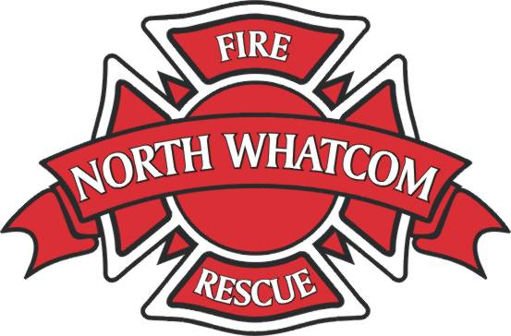 North Whatcom Fire and Rescue

Semper paratus

AUTHORIZATION TO RELEASE MEDICAL RECORDS
This Authorization must be written, dated, and signed by the patient or by a person authorized by law to give authorization.

I authorize North Whatcom Fire and Rescue to release a copy of the medical record obtained and/or recorded by their employees to the person identified below. I specifically authorize the release of immunization and testing information as a part of the medical record.

I understand that information used or disclosed pursuant to this Authorization may be subject to re-disclosure by the recipient and no longer subject to privacy protections provided by law.

Patient Name:
Patient Date of Birth: |  | Social Security No.
Purpose of Request:

Please release to:
Phone:

Please release records by: (Check One)
Fax:
Mail:

This Authorization may be revoked at any time. To revoke this Authorization, I understand that I must do so by written request to North Whatcom Fire and Rescue at the address below. The only exception is when action has been taken in reliance on the Authorization. Unless revoked earlier, this consent will expire 180 days from the date of signing or shall remain in effect for the period reasonably needed to complete the request.

I acknowledge that I have read the provisions in the Authorization and that I have the right to refuse to sign this Authorization. I understand and agree to its terms.
Date |  | Signature of Patient or Other Person  Authorized to Sign for Patient
Relationship to Patient (if applicable) |  | Printed Name

North Whatcom Fire and Rescue * 4142 Britton Loop, Bellingham, WA 98226 * (360) 318-9933 * (360) 734-7139

