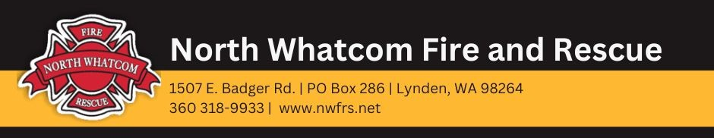
FOR IMMEDIATE RELEASE

Date: March 27, 2024
Contact: Chief Jason Van Der Veen | 360-318-9933 | jvanderveen@nwfrs.com

Board of Fire Commissioners passes fire levy lid lift resolution
Proposition will appear on the August 6, 2024, primary election ballot

Lynden, WA – The North Whatcom Fire and Rescue (NWFR) Board of Fire Commissioners unanimously passed a resolution to place a fire levy lid lift on the August 6, 2024, primary election ballot. The lid lift would fund additional firefighters to respond to higher call volumes and replace engines and equipment that have reached the end of their usable lives.

“Our call volumes have almost doubled in the last 10 years, and we need additional personnel to respond to calls,” Fire Chief Jason Van Der Veen said. “Revenue from our fire levy is not keeping up with the demand for emergency services.”

As a result, NWFR is experiencing longer response times. More firefighters and facility improvements are needed to handle the growing demand for emergency services and reduce response times.

If approved by voters, the fire levy lid lift would fund:

- Up to eight emergency personnel over six years to respond to higher call volumes, meet staffing requirements at fire stations, and put into service another response unit for EMS
- Replacement of a ladder truck and three engines that have reached the end of their usable lives

Hiring more personnel will allow the district to adequately staff its fire stations to decrease response times, as well as reduce reliance on mutual aid from other agencies. Having to rely on mutual aid puts additional strain on those agencies and can take longer to reach people in an emergency.

More staffing also means NWFR can put into service another response unit for medical emergencies. This is critical because EMS calls have increased by 50 percent and now account for most of all calls – 71 percent. When emergency personnel are out-of-service transporting patients to St. Joseph Hospital in Bellingham, NWFR must rely on mutual aid due to staffing shortages. This can delay response times for other emergency calls that come in during this time.

The lid lift would also help fund the replacement of Station 63 in Birch Bay (a bond may be needed to complete this project) to improve response times and service reliability in the area. Station 63 is the district’s busiest station.

The fire district is asking voters to change the fire levy from $0.76 per $1,000 of assessed property value to $1.10. If approved by voters, this would be the first levy lid lift in almost 20 years.

The $0.34 lid lift would cost the owner of a $500,000 home an additional $14.16 per month or $170 per year.

Learn more at www.nwfrs.net. Fire Chief Jason Van Der Veen also welcomes questions at 360-318-9933 or jvanderveen@nwfrs.com.

###

North Whatcom Fire and Rescue provides fire and life safety services to 33,800 people over 156 square miles, including the communities of Lynden, Laurel, Blaine, Custer, Birch Bay and Semiahmoo. NWFR also serves the residents of Whatcom County Fire District 4 through a contract agreement. In 2023, NWFR responded to 5,753 calls – of which 71 percent were for emergency medical service (EMS). Call volumes have almost doubled in the last 10 years, and overlapping calls happen 30 percent of the time. NWFR operates under a balanced budget and is debt-free.

